**QUESTIONS FOR THE EXAMINATION IN THE DISCIPLINE:**

**"HOSPITAL SURGERY, PAEDIATRIC SURGERY"**

1. What is an absolute sign of inoperable gastric cancer?

2 Which artery does the appendicular artery branch from?

3 What is the outside of the femoral ring limited by?

4. With what diseases is femoral hernia not differentiated?

5. What can not be provoked by pain syndrome in colonic diverticulosis?

6. What most often characterises the pain syndrome in intestinal obstruction?

7. What symptom is characterised by painful palpation in the left rib-vertebral angle in acute pancreatitis?

8. What is not used in the diagnosis of oesophageal foreign bodies?

9. What examination gives the most objective information in the diagnosis of acute intestinal obstruction?

10. What is the least significant clinical sign is in the diagnosis of abdominal cavity organ injuries?

11. What investigation plays a leading role in the diagnosis of various forms of chronic paraproctitis?

12. What is crucial in the differential diagnosis of chronic pancreatitis and tumour lesions of the pancreas?

13. What is not allocated in the classification of abdominal trauma?

14. In the clinical course of a perforated gastroduodenal ulcer the following periods are distinguished: 1) dehydration; 2) shock; 3) imaginary well-being; 4) the height of the disease; 5) widespread peritonitis. Select the correct combination of answers?

15. What is not included in the complex of conservative treatment of chronic ischaemia of the lower extremities?

16. What signs of the disease are not characteristic of the initial stage of acute pancreatitis?

17. What investigation is contraindicated in the first days of the disease in patients with acute pancreatitis?

18. What symptom is considered positive if the breast tumour disappears in the supine position?

19. What cysts are not found in the mediastinum?

20. How many segments are distinguished in the trunk of the superior mesenteric artery?

21. In the course of peritonitis the following stages are distinguished: 1) early; 2) toxic; 3) reactive; 4) irreversible changes; 5) terminal. Select the correct combination of answers?

22. In the perforation of which ulcers is vagotomy indicated?

23. What is the leading pathophysiological factor of acute haemorrhoids?

24. What factors do not contribute to venous thrombosis in the postoperative period?

25. Where is usually located the internal opening of the fistulous passage in chronic paraproctitis?

26. How much does intravenous infusion of 1 litre of 0.9% sodium chloride solution increase the OCC?

27. In what cases is the bleeding time prolonged?

28. What disease can not be caused by secondary hypersplenism?

29. Which method of radiological examination is most informative in colorectal cancer?

30. What breast disease is characterised by discharge of blood from the nipple?

31 . What type of diaphragmatic hernia is not complicated by impingement?

32. What disease is characterised by forced position of the patient with legs brought to the abdomen and plank-like tension of the abdominal muscles?

33. What is the essence of haemorrhoidectomy according to Milligan-Morgan?

34. With what disease hemorrhoids are not differentiated?

35. What is the primary purpose of haemotransfusion in patients?

36. What is Littre's hernia?

37. What can hernia of the oesophageal orifice of the diaphragm cause?

38. How is the hernia sac formed in congenital inguinal hernia?

39. What is the name of this examination?

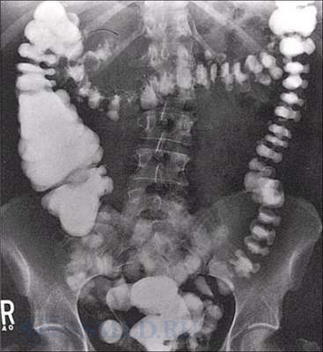

40. What is the name of this type of local anaesthesia?

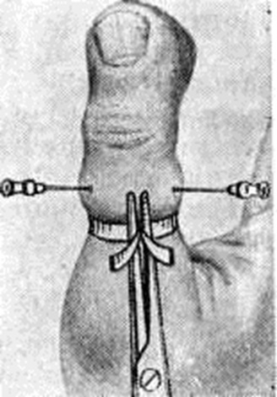

41. What is primarily associated with the development of dumping syndrome?

42. Mainly by what features is the diagnosis of acute disseminated peritonitis established preoperatively?

43. The diagnosis of abdominal cavity organ damage will help to confirm the following methods of investigation: 1) laparocentesis with the use of a balloon catheter; 2) laparoscopy; 3) rheovasography; 4) review radiography of the abdominal cavity; 5) cavography. Select the correct combination of answers?

44. Which author is named after the disease "diffuse toxic goitre"?

45. What is not characteristic of Crohn's disease?

46. Which examination is of leading importance in the detection of bronchiectasis?

47. Gastroduodenal ulcer complicated by haemorrhage is characterised by: 1) increased abdominal pain; 2) reduction or disappearance of pain syndrome; 3) vomiting coffee grounds; 4) dysphagia; 5) melena. Select the correct combination of answers?

48. Which sign is not characteristic of oesophageal hernia of the aperture of the diaphragm?

49. Which symptom is not characteristic of dumping syndrome?

50. To diagnose possible distant metastases in rectal cancer, one should use: 1) rectal rheography; 2) cholangiography; 3) abdominal ultrasound; 4) splenoportography; 5) chest radiography. Select the correct combination of answers?

51. Which radiological method is not used to diagnose liver disease?

52. Which study is the most informative for diagnosing the site of occlusion of the main veins of the lower limbs?

53. What methods are used to diagnose acute appendicitis?

54. What method is not used to diagnose acute appendicitis?

55. What is not considered in the differential diagnosis between lower lobe right-sided pneumonia and acute appendicitis?

56. Ileofemoral phlebothrombosis is characterised by: 1) rasping pain in the limb; 2) hyperaemia of the plantar surface of the foot; 3) swelling of the limb from the foot to the inguinal crease; 4) pale cyanotic colour of the limb; 5) pain in the calf muscles with strong flexion of the foot. Select the correct combination of answers?

57. What is characteristic of compensated pyloroduodenal stenosis?

58. Bleeding gastroduodenal ulcer is characterised by the following symptoms: 1) increased abdominal pain; 2) absence of pain syndrome during this period; 3) frequent liquid stools; 4) vomiting of coffee grounds; 5) melena. Select the correct combination of answers?

59. What is not characteristic of a bleeding duodenal ulcer?

60. Which blockade is not used for pain relief in acute pancreatitis?

61. Which operation is not used to treat obliterative atherosclerosis?

62. What interventions are not used in the treatment of paralytic ileus?

63. What is not characteristic of mechanical jaundice due to choledocholithiasis?

64. What medical device is used to stop bleeding from oesophageal varices?

65. Which symptom is not characteristic of acute appendicitis?

66. What is not characteristic of acute mediastinitis at the onset of the disease?

67. What is not characteristic of acute disturbance of the mesenteric circulation?

68. What is not characteristic of acute pancreatitis?

69. Acute deep vein thrombosis of the lower leg is characterised by: 1) acute pulsating pain in the limb; 2) small oedema of the foot and lower leg; 3) impaired pain and tactile sensitivity of the distal parts of the limb; 4) positive Homans' symptom; 5) pain in the calf muscles with compression of the lower leg. Select the correct combination of answers?

70. What is not characteristic of grade II acute limb ischaemia?

71. Acute obstruction of the main arteries of the lower limb is characterised by: 1) pain in the affected limb; 2) swelling of the lower leg and foot; 3) stiffness and contracture of the limb muscles; 4) hyperaemia of the skin of the feet and fingers; 5) sensory disturbance. Select the correct combination of answers?

72. Which sign is not characteristic of an uncomplicated inguinal hernia?

73. What symptom is not characteristic of peritonitis?

74. What symptoms are characteristic of perforative appendicitis?

75. What is characteristic of perforative gastroduodenal ulcer?

76. What clinical signs are not characteristic of perforation of the abdominal hollow organ?

77. What signs are not characteristic of portal hypertension with subhepatic block?

78. What is not characteristic of post-thrombotic syndrome of the lower extremities?

79. Which histological form of cancer is most characteristic of colorectal neoplasms?

80. What method of bronchial tree sanation is the most effective in patients with bronchiectatic disease?

81. Thyrotoxic crisis is characterised by: 1) mental and motor restlessness; 2) high body temperature; 3) decreased body temperature; 4) pain in the heart and abdomen; 5) dry skin. Select the correct combination of answers?

82. What medical instrument is commonly used for thrombo- and embolectomy?

83. Which sign is not characteristic of chronic pancreatitis?

84. Which complication is not characteristic of cirrhosis of the liver?

85. In which disease is not indicated drainage of the pleural cavity with permanent aspiration?

86. After which gastric surgery is duodenogastric reflux least common?

87. Which complication cannot be caused by cholelithiasis?

88. In which localisation of gastric cancer is delayed evacuation primarily characteristic?

89. What anatomical structure is not contained in the posterior mediastinum?

90. What are the most common diaphragmatic hernias?

91. Which disease causes mesenteric thromboembolism less frequently?

92. At the level of what part of the oesophagus are its foreign bodies most frequently localised?

93. What complication is characterised by disappearance of pain and appearance of melena in duodenal ulcer?

94. In what cases does the ischaemic type of infarction of the intestines occur?

95. Diffuse forms of breast cancer include:1) mastitis-like cancer; 2) lobular cancer; 3) erysipeloid cancer ; 4) fibroadenomatosis; 5) pancreatic cancer. Select the correct combination of answers?

96. What refers to infusion agents that do not have a volume-replacement effect?

97. What factors do not lead to the non-occlusive type of acute intestinal ischaemia?

98. The major complications of nonspecific ulcerative colitis and Crohn's disease include: 1) portal hypertension; 2) gastric haemorrhage; 3) toxic dilatation of the colon; 4) perforation of intestinal ulcers; and 5) anal jejunum insufficiency. Select the correct combination of answers?

99. Which form is not classified as acute pancreatitis?

100. What symptoms are classified as peritoneal in acute appendicitis?

101. What does not belong to predisposing factors in the development of varicose veins?

102. What is not an early symptom of mesenteric thromboembolism?

103. What hernias are not among their rare forms?

104. What are not among the symptoms of acute cholecystitis?

105. What does not belong to the syndrome of operated stomach of functional type?

106. Risk factors for gastric cancer include: 1) adenomatous gastric polyps; 2) blood group 0 (1); 3) achlorhydria after gastric resection; 4) Mallory-Weiss syndrome; 5) Menetrier's disease. Select the correct combination of answers?

107. Which form is not classified as chronic pancreatitis?

108. What acute surgical pathology is depicted in this image?

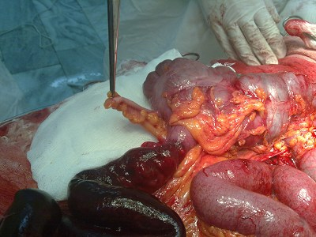

109. What is a characteristic complication of choledocholithiasis?

110. What pathology is presented on the radiograph??

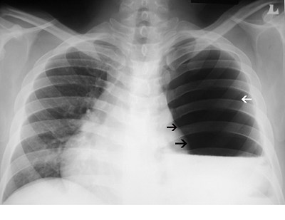

111. What rectal pathology is represented in this figure?

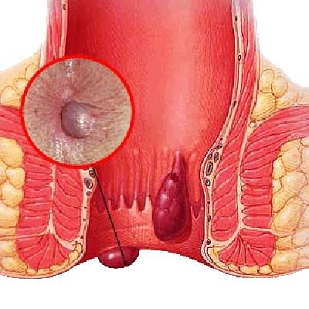

112. Which of the following symptoms are characteristic of a bleeding gastroduodenal ulcer?

113. Which of the following factors contribute to abdominal hernias?

114. Which of the following factors are indications for surgical treatment of oesophageal hiatal hernia? 1) elderly age of the patient; 2) development of oesophageal stricture; 3) frequent oesophageal bleeding; 4) presence of hernia for more than 2 years; 5) shortening of the oesophagus. Indicate the correct combination of answers?

115. Which mediastinal tumours are often accompanied by myasthenic syndrome?

116. Which of the following metabolic disorders is most characteristic of acute pancreatitis?

117. What investigation should be the first priority in suspicion of traumatic injury to the abdominal hollow organ?

118. What metabolic disorder is characteristic of decompensated ulcerative pylorostenosis?

119. What combination of clinical symptoms corresponds to Courvoisier syndrome?

120. What type of intestinal anastomosis is shown in the figure?

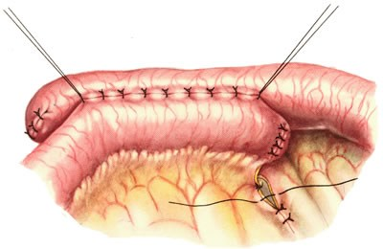

121. What type of intestinal fistula is represented in the diagram?

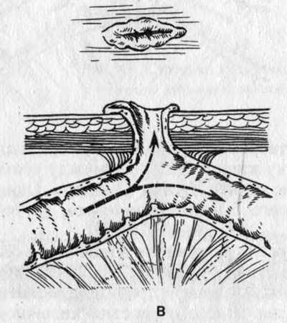

122. What type of intestinal fistula is represented in the diagram?

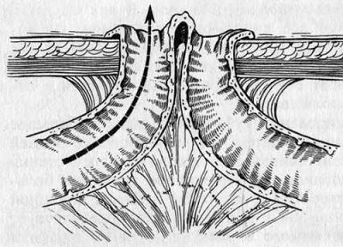

123. Which type of intestinal fistula is shown in the diagram?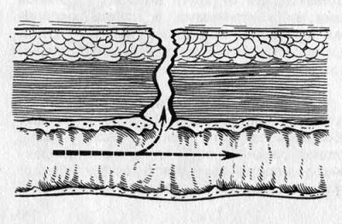

124. Which type of intestinal obstruction is represented in the figure?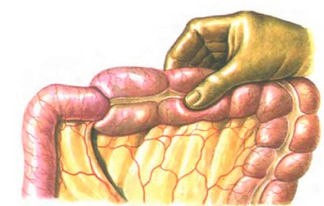

125. Which type of intestinal obstruction is represented in the figure?

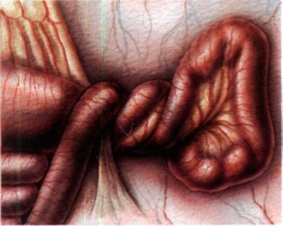

126. What should be the therapeutic tactics in endoscopic picture of ulcer bleeding recurrence?

127. Which of the additional ways of breast cancer treatment is used most often?

128. Which of the methods of preoperative examination is the most informative in the assessment of biliary tract pathology?

129. Which of the methods is the most reliable in determining the exact localisation of the source of bleeding from the upper GI tract?

130. Which of the listed organs is topographically most closely related to the thyroid gland?

131. Which method of investigation is the least informative in the diagnosis of oesophageal hiatal hernia?

138. Clinical manifestations of haemotransfusion shock: 1) abdominal pain; 2) tachycardia; 3) drop in blood pressure; 4) low back pain; 5) vomiting. Select the correct combination of answers?

139. What % of donor blood should be used to replenish massive blood loss of 2-3 litres?

140. What does not include a complex of therapeutic measures in spilt purulent peritonitis?

141. Which organ is the first to show compression syndrome in mediastinal tumours?

142. The criteria determining to a large extent the probability of recurrence of ulcer haemorrhage are considered to be: 1) gender of patients; 2) size of ulcer; 3) duration of disease; 4) nature of thrombus in the ulcer; 5) severity of bleeding. Select the correct combination of answers?

143. What does not belong to blood substitutes of haemodynamic action?

144. Blood substitutes intended for parenteral nutrition are: 1) dextrans; 2) amino acid mixtures; 3) gelatin solutions; 4) 20-40% glucose solutions; 5) fat emulsions. Select the correct combination of answers?

145. In which disease is hemoptysis not observed?

146. What type of intestinal obstruction is characterised by bloody discharge from the rectum?

147. What is the mortality rate after appendectomy?

148. Where should we start treatment of acute hypovolemia?

149. What parts of the intestine are infarcted when the embolus is localised in the first segment of the trunk of the superior mesenteric artery?

150. What parts of the intestine are infarcted when the embolus is localised in the second segment of the trunk of the superior mesenteric artery?

151. Radiation and chemotherapy are the main methods of treatment of: 1) mediastinal teratomas; 2) thymus gland tumours; 3) mediastinal lymphosarcomas; 4) lymphogranulomatosis; 5) ganglioneuromas. Select the correct combination of answers?

152. What is mediastinotomy according to Razumovsky?

153. Where is Schnitzler's metastasis localised?

154. The method of programmed relaparotomy for abdominal cavity sanation in patients with peritonitis is indicated: 1) in local unrestricted peritonitis; 2) in forming interintestinal abscesses; 3) in spilt serous-fibrinous peritonitis; 4) in anaerobic non-clostridial peritonitis; 5) in all peritonitis of appendicular etiology. Select the correct combination of answers?

155. Multiple small abscesses in the liver occur in which disease?

156. What does not affect the choice of therapeutic tactics in acute intestinal obstruction?

157. What may suggest mesenteric thromboembolism?

158. What pathology is depicted in the presented image?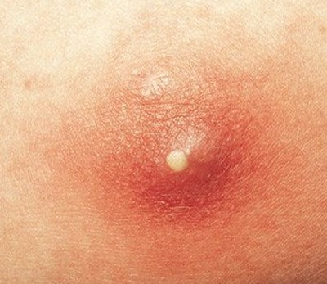

159. What pathology is depicted in the image shown?

160. What pathology is depicted in the image shown?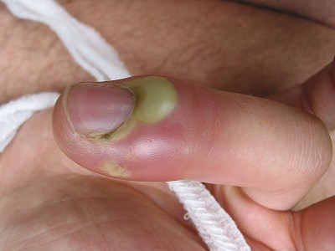

161. What pathology is depicted in the image shown?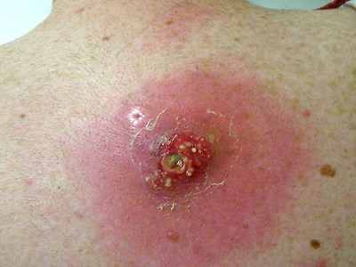

162. What pathology is depicted in the image shown?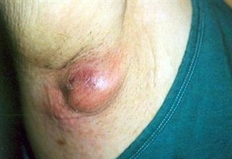

163. What pathology is depicted in the image shown?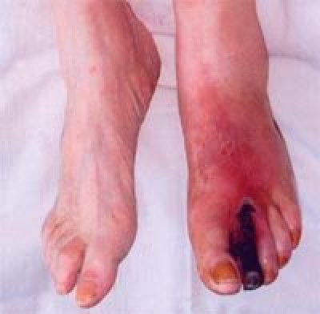

164. What pathology is depicted in the image shown?

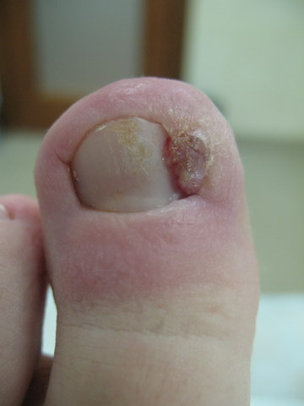

165. What are the most common complications of blood substitute transfusion?

166. What is the most likely complication of a duodenal ulcer penetrating into the head of the pancreas?

167. What is the most reliable method for the diagnosis of colonic polyps?

168. What is the most reliable method of investigation when acute pancreatitis is suspected?

169. Which method is the most informative for the diagnosis of colonic diverticulosis?

170. What is the most reliable method of investigation for the diagnosis of pancreatic cysts?

171. What is the most reliable method of investigation for the diagnosis of vascular disease of the lower extremities?

172. Which method of investigation is the most reliable for the diagnosis of acute calculous cholecystitis?

173. What is the most reliable method of investigation for varicose veins of the lower limbs?

174. What is the most reliable method of investigation in dumping syndrome?

175. The most informative investigations in suspected oesophageal cancer are: 1) esophagomanometry; 2) esophagoscopy with biopsy; 3) radiological examination of the oesophagus and stomach; 4) computed tomography; 5) oesophageal ultrasound. Select the correct combination of answers?

176. The most informative methods of preoperative examination of patients with mechanical jaundice are: 1) intravenous cholangiography; 2) ultrasound; 3) ERCG; 4) percutaneous transhepatic cholangiography; 5) laparoscopy. Select the correct combination of answers?

177. What is the most objective indicator for determining the severity of blood loss?

178. Which operation is the most optimal surgical method of treatment of patients with postthrombotic syndrome?

179. What is the most preferable method for intestinal intubation in spilt purulent peritonitis?

180. What is the earliest and most constant symptom in acute small bowel obstruction?

181. What is the most common surgical procedure for severe dumping syndrome after Bilroth-2 gastric resection?

182. What is the most rational route of antibiotic administration in patients with liver abscess?

183. What is the most rational surgical procedure for oesophageal hiatal hernia of the diaphragm?

184. Which gastric cancer has the most scanty clinical manifestations?

185. Which gastric cancer is the most difficult to diagnose?

186. What is the most characteristic symptom of gastroduodenal haemorrhage?

187. What is the most characteristic symptom of an acute lung abscess?

188. What is the most characteristic symptom in uncomplicated oesophageal diverticula?

189. What is the character of pain in acute pancreatitis?

190. What is the most reliable clinical sign of dumping syndrome?

191. The most characteristic clinical signs in mediastinal tumours are: 1) chest pain; 2) difficulty swallowing; 3) subcutaneous emphysema; 4) facial lividity and swelling; 5) increased body temperature. Select the correct combination of answers?

192. What is the most common localisation of breast cancer?

193. What is the most common cause of death in destructive pancreatitis?

194. What is the most common source of massive upper GI bleeding?

195. At what period of a woman's life is acute mastitis most common?

196. In what localisation of ulcer is the most frequent severe gastroduodenal bleeding?

197. What is the most common complication of diverticulosis of the sigmoid colon?

198. What is the most frequent localisation of anal fissure?

199. What is the most frequent localisation of gastric cancer?

200. What is the most common cause of arterial emboli?

201. What is the most common cause of false pancreatic cyst formation?

202. State the most common cause of spontaneous pneumothorax?

203. What is the most common localisation of rectal cancer?

204. What is the most frequent and constant symptom of rectal cancer?

205. What is the most frequent indirect sign of acute pancreatitis on gastroduodenoscopy?

206. What is the most common complication following subtotal thyroid resection?

207. What is the most common complication of an anterior wall ulcer of the duodenum?

208. What is the most frequent symptom of acute pancreatitis?

209. What is the most common cause of mesenteric embolism?

210. Select the most effective method of treatment for chronic anal fissure?

211. What is the most effective method of preventing the progression of varicose veins?

212. At what diameter of a polyp is there the greatest probability of its malignisation?

213. Which colon polyps have the greatest tendency to malignisation?

214. What inguinal hernia is characterised by the presence of a testicle in the hernia sac?

215. In which complication is external drainage of a pancreatic cyst indicated?

216. What sign is not characteristic of peptic ulcer disease?

217. Which statement is incorrect for the manifestations of acute appendicitis?

218. Failure to detect abdominal aortic pulsation in the epigastrium in acute pancreatitis is a symptom?

219. From what layer of the intestinal wall begin necrotic changes in strangulation intestinal obstruction?

220. Where does emergency treatment for valve pneumothorax begin?

221. What is the lower wall of the inguinal canal?

222. What is evidence of acute destructive cholecystitis on ultrasound examination?

223. What sign does not allow to judge about insufficiency of arterial blood flow of the extremities?

224. What sign is indicative of hollow organ damage in abdominal trauma?

225. What test does not allow to judge about the state of the valve apparatus of superficial and communicating veins?

226. In whom is observed most often obliterative atherosclerosis?

227. What is the most common cause of obturator intestinal obstruction?

228. In what cases is bile stained fluid not observed in the abdominal cavity?

229. What dangerous complication is caused by phlebothrombosis of the lower extremities?

230. In what pathology in the region of the diaphragm is operative treatment primarily necessary?

231. In what case of duodenal ulcer is operative treatment not usually indicated?

232. What is the most characteristic radiological sign of the driving loop syndrome?

233. What is the optimum length of the skin incision in an adult during Volkovich-Dyakonov appendectomy?

234. What disease is a complication of erosive-ulcerative esophagitis?

235. What cannot be a complication of acute lung abscess?

236. What complication is not characteristic of thyroid surgery?

237. What complication is not caused by Crohn's disease?

238. Complications of cholelithiasis may include: 1) Mallory-Weiss syndrome; 2) gallbladder empyema; 3) acute pancreatitis; 4) duodenal ulcer; 5) internal biliodigestive fistula. Select the correct combination of answers?

239. What cannot be a complication of postthrombotic disease of the lower extremities?

240. What is the main indication for surgery in acute destructive pancreatitis?

241. What is the chief complaint in haemorrhoids?

242. What is the main clinical sign of endemic goitre?

243. Which criterion is the main criterion in the classification of peritonitis?

244. What is the main method of treatment of acute purulent paraproctitis?

245. What is the main indication for portocaval anastomosis in patients with portal hypertension?

246. What is the main route of lymphatic outflow from the breast?

247. What is the main radiological sign of central lung cancer?

248. What is the major factor in deciding whether surgical treatment of chronic cholecystitis is necessary?

249. What is the main factor determining therapeutic tactics in acute arterial insufficiency of the extremities?

250. The main methods of diagnostics of gastric cancer are: 1) investigation of gastric secretion; 2) radiological examination; 3) gastroscopy with biopsy; 4) endoscopic ultrasound; 5) radioisotope method. Select the correct combination of answers?

251. The main factors contributing to the development of lung abscess in patients with pneumonia are: 1) heart disease; 2) violation of bronchial patency; 3) vascular thrombosis in the zone of inflammation of lung tissue; 4) spontaneous pneumothorax in the anamnesis; 5) high virulence of microflora. Select the correct combination of answers?

252. In which case is it indicated to leave a tampon in the abdominal cavity after open appendectomy?

253. Which disease should not be differentiated with mesenteric circulation disorder?

254. Specify the disease with which acute appendicitis should not be differentiated?

255. What symptom is not a distinctive sign of acute appendicitis in children of younger age group?

256. Specify the palliative operation in case of cancer localisation in the pyloroantral part of the stomach with sprouting of neighbouring organs?

257. Specify the palliative operation performed for cancer of the cardiac part of the stomach with sprouting of neighbouring organs?

258. What dangerous complication can develop in the presence of paraesophageal hernia in a patient?

259. What disease should not be differentiated with which inguino-monochondral hernia?

260. In whom primary gangrenous appendicitis is most often found?

261. What would be the primary intervention for a pinched hernia in the elderly?

262. What test does a physician not perform before performing a haemotransfusion?

263. What is the anterior wall of the inguinal canal?

264. Name a disease that is not complicated by peritonitis?

265. Liver jaundice develops: 1) in biliary tumours; 2) in cirrhosis of the liver; 3) in viral hepatitis; 4) in poisoning with arsenic compounds; 5) in Budd-Chiari disease. Select the correct combination of answers?

266. How is acute intestinal obstruction classified by mechanism of onset?

267. What is the time frame for a patient undergoing late oesophageal bouching for a burn stricture?

268. What is an indication for surgical treatment of anal fissure?

269. What is not an indication for surgical treatment of non-specific ulcerative colitis?

270. What is an indication for emergency surgery in spontaneous repositioning of a strangulated hernia?

271. Indications for surgery in patients with chronic pancreatitis are: primary chronic form of the disease; 2) virsungolithiasis; 3) endocrine insufficiency of the pancreas; 4) pancreatic duct strictures; 5) severe painful forms of the disease. Select the correct combination of answers?

272. Transverse pain resistance of the anterior abdominal wall in the projection of the pancreas in acute pancreatitis is a symptom of?

273. If after surgery for hyperthyroid goitre the patient began to choke, voice hoarseness appeared, what postoperative complication should be thought about?

274. What pathological syndrome cannot be observed after pyloroplasty and selective proximal vagotomy for a perforated ulcer?

275. After which operation, diseases of the operated stomach most commonly occur?

276. The sign of damage to what organ is the appearance of crepitation in the lumbar region after blunt abdominal trauma?

277. By compression of what anatomical structure is the appearance of Gorner's syndrome in mediastinal tumours caused?

278. In what disease is possible the appearance of trophic disorders and even gangrene of the toes of the feet with preserved pulsation of peripheral arteries?

279. Specify the limits of normal values of bilirubin in the blood?

280. What disease cannot be the cause of the development of portal hypertension?

281. What operation is indicated for stage IV antral gastric cancer with sprouting of neighbouring organs and decompensated stenosis?

282. At what distance does pain during walking occur in the calf muscles in the presence of chronic arterial insufficiency stage II A in a patient?

283. What treatment is indicated for an abscess of the Douglas space?

284. What is the most reasonable surgical treatment for bacterial liver abscess?

285. What operation is indicated in case of unsuccessful conservative therapy of fibrinous ulcerative reflux esophagitis?

286. What surgical intervention is indicated when a patient has oedematous pancreatitis with omentobursitis?

287. If a solitary nodule in the thyroid gland is detected, the following methods of investigation are indicated: 1) radionuclide scanning of the thyroid gland; 2) radiological examination of the chest organs; 3) ultrasound of the thyroid gland; 4) examination of the thyroid hormone level; 5) puncture biopsy of the thyroid gland. Select the correct combination of answers?

288. What treatment is indicated for gangrene of the middle lobe of the lung?

289. What is the haemoglobin level in mild gastroduodenal bleeding?

290. What intervention is not indicated in haemorrhagic pancreonecrosis?

291. What is the most reasonable operation for decompensated pyloroduodenal stenosis?

292. What is not used in the diagnosis of acute intestinal obstruction?

293. What operation is indicated for oesophageal diverticula?

294. At what distance does pain during walking occur in the calf muscles in the presence of chronic arterial insufficiency stage I in the patient?

295. What is not used in the treatment of diffuse mastitis?

296. What symptom is not detected in sigmoid colon ingestion?

297. What is the main treatment for closed uncomplicated unilateral rib fractures?

298. Which operation is indicated for bleeding gastric ulcer and low operative risk?

299. What is not used in the treatment of acute pleural empyema?

300. What plastics are used in the treatment of umbilical hernias in children?

301. What treatment is indicated for a patient with acute total pleural empyema?

302. Which colon is most commonly affected in nonspecific ulcerative colitis?

303. What operation is indicated in operable cancer of the outlet of the stomach with stenosis?

304. What operation is indicated for a patient with cirrhosis of the liver with marked hypersplenism?

305. What stage of the disease can be thought about in the presence of gastric tumour within the mucous membrane and submucous layer, without regional and distant metastases?

306. What is transfused to patients with haemostatic purpose in gastrointestinal bleeding?

307. What operations depending on time can be used in calculous cholecystitis?

308. State the symptom present in acute mediastinitis as opposed to purulent pericarditis?

309. Which complication is not characteristic of acute pancreatitis?

310. Which symptom is not seen in acute phlegmonous appendicitis?

311. What symptom is not seen in parenchymatous organ damage of the abdominal cavity?

312. What clinical sign is not observed in spleen injury?

313. What clinical sign is not seen in a subdiaphragmatic abscess?

314. Which examination is performed first when acute intestinal obstruction is suspected?

315. What therapeutic agents are inappropriate in the treatment of postoperative bowel paresis?

316. What measures are performed in case of spilt purulent peritonitis of appendicular origin?

317. What is the most characteristic clinical sign observed in mid-thoracic oesophageal cancer?

318. What parts of the intestine are infarcted when the embolus is localised in the third segment of the trunk of the superior mesenteric artery?

319. How many cm. should be set back from the zone of necrosis at resection of the leading part of the pinched intestine?

320. For what time barium in a healthy person in the radiological study of the intestine passes the way from the stomach to the cecum?

321. What are the most appropriate medications to use for reflux gastritis?

322. What should the tactics be in case of recurrence of ulcerative gastroduodenal bleeding?

323. In Leriche's syndrome, pulsation is weakened or absent: 1) on the arteries of the foot; 2) on the hamstring arteries; 3) on the carotid arteries; 4) on the brachial arteries; 5) on the femoral arteries: Select the correct combination of answers?

324. The following types of surgery are used for the driving loop syndrome: 1) subdiaphragmatic stem vagotomy; 2) reconstruction of gastrointestinal anastomosis into Roux anastomosis; 3) subtotal gastric resection; 4) duodenojejunostomy; 5) reconversion of Bilroth-2 to Bilroth-1 anastomosis. Select the correct combination of answers?

325. Which operation is the most appropriate in case of a formed false cyst of the pancreatic body?

326. The most common findings in teratomas of the mediastinum are: 1) chest pain; 2) joint swelling; 3) dry cough; 4) dyspnoea; 5) dysphagia. Select the correct combination of answers?

327. What treatment is indicated for total atelectasis of one of the lungs?

328. Which chest trauma victims have the most severe respiratory dysfunction?

329. What victims of chest trauma are not subject, as a rule, to urgent and urgent surgical treatment?

330. What should be the first priority in eliminating post-haemorrhagic pathophysiological disorders?

331. What operation is indicated for fibroadenoma of the breast?

332. What surgical intervention is not used in chronic pancreatitis of cholangiogenic origin?

333. Which operation would be the optimal treatment for femoral artery embolism with acute limb ischaemia of II B degree?

334. What is the most appropriate surgery for complicated peptic ulcer disease in the presence of chronic duodenal patency disorder?

335. Signs of acute tamponade of the heart at its wounding will be: 1) sharp dyspnoea; 2) cyanosis of skin and mucous membranes; 3) dilation of superficial neck veins; 4) increased blood pressure; 5) increasing subcutaneous emphysema. Select the correct combination of answers?

336. Which indicator of biochemical blood analysis will be most informative in acute pancreatitis in the initial period?

337. Which extragastric pathology cannot be the cause of gastrointestinal bleeding?

338. What cannot be the cause of acute mediastinal suppurative processes?

339. Causes of ulcer recurrence after peptic ulcer surgery include: 1) removal of a significant part of the stomach; 2) incomplete removal of the antral mucosa; 3) gastric ischaemia after SPV; 4) inadequate vagotomy; 5) Zollinger-Ellison syndrome. Select the correct combination of answers?

340. What cannot be the cause of the development of paralytic intestinal obstruction?

341. What can provoke the development of acute intestinal obstruction?

342. In what case is abdominal lavage during surgery in patients with acute appendicitis indicated?

343. Which sign is not a characteristic manifestation of thyrotoxicosis?

344. What is not a direct sign of lung tissue damage in blunt chest trauma?

345. Are cyanotic spots on the lateral walls of the abdomen in acute pancreatitis a symptom?

346.The radical operations for gastric cancer are: 1) antrumectomy with gastrojejunal anastomosis; 2) distal subtotal gastric resection; 3) gastrectomy; 4) Hofmeister-Finsterer resection of 2/3 of the stomach; 5) proximal subtotal gastric resection. Select the correct combination of answers?

347. Radical operations for liver cancer are considered to be: 1) omentohepatopexy; 2) lobectomy; 3) hemihepatectomy; 4) atypical liver resection; 5) liver transplantation. Select the correct combination of answers?

348. Which disease is not characterised by the development of mesenteric artery thrombosis?

349. What factor contributes to the development of obliterative atherosclerosis?

350. Specify a non-existent anatomical narrowing of the oesophagus?

351. With what disease is rectal cancer not differentiated?

352. What is the distance of pain during walking in the calf muscles in the presence of chronic arterial insufficiency stage II B?

353. In which pathology does mediastinal emphysema not occur?

354. What abdominal cavity pathology is characterised by the radiological signs shown on the image?

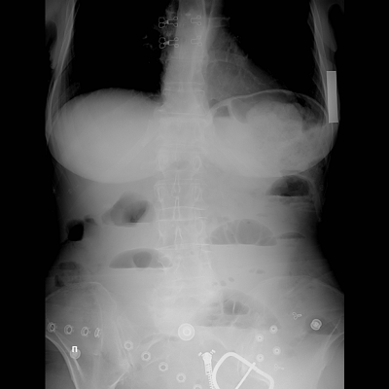

355. Radiological signs of which colonic pathology are shown in the given image?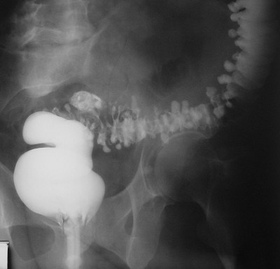

356. What is crucial in the differential diagnosis of acute appendicitis with a disturbed ectopic pregnancy?

357. What is the most common cause of peritonitis?

358. In what situations is selective proximal vagotomy not performed?

359. For which disease is Pribram's symptom pathognomonic?

360. What is Mallory-Weiss syndrome?

361. What postgastroresection syndrome would correspond to the appearance of such signs as weakness, tachycardia, sweating in the patient after surgery?

362. At what level is vascular surgery for thrombosis of the superior mesenteric artery feasible?

363. Specific pararectal fistulas may occur in: 1) tuberculosis; 2) gonorrhoea; 3) syphilis; 4) diverticulosis; 5) actinomycosis. Select the correct combination of answers?

364. Splenomegaly is not seen in which disease?

365. In which disease does spontaneous rupture of the spleen not occur?

366. State a factor that does not contribute to the development of strangulation intestinal obstruction?

367. What is the most common mediastinal neoplasm?

368. Which tumour is the most common among malignant neoplasms of the oesophagus?

369. What is the shelf life of fresh frozen plasma at minus 25 C.

370. What disease is characterised by regurgitation of scarlet frothy blood?

371. Where is the sphincter of Lutkens located?

372. Impingement of what organ can be suspected when determining the tympanic sound above the hernial bulge during percussion?

373. What is not a typical complication of acute appendicitis?

374. State the cause that most commonly contributes to the development of mesenteric vein thrombosis?

375. State the most adequate operation for a chronic lung abscess occupying 1 to 3 segments?

376. Specify the correct option of performing pleural puncture for hydrothorax?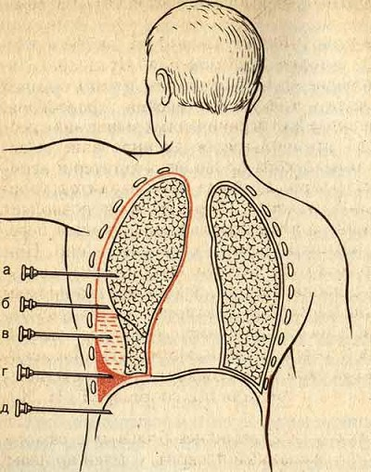

377. Indicate the symptoms most commonly seen in sliding oesophageal hernia: 1) heartburn; 2) sternal pain; 3) melena; 4) diarrhoea; 5) constipation. Indicate the correct combination of answers?

378. Indicate in which hernias does the pain syndrome increase in the horizontal position of the patient?

379. What disease corresponds to the presented ultrasound image?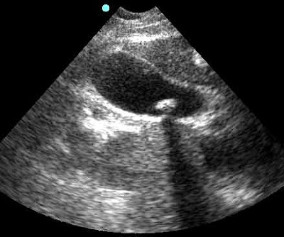

380. With what diseases should a pinched femoral hernia be differentiated?

381. Which peritonitis does not have fibrinous deposits on the peritoneum?

382. What is the character of abdominal pain in acute destructive pancreatitis?

383. What factor does not determine the nature and extent of surgery in acute mesenteric thromboembolism?

384. What is the characteristic position of a patient with acute mediastinitis?

385. What complication is characteristic of acute pancreatitis?

386. What clinical sign is not characteristic of an abscess of Douglas' space?

387. What is not a characteristic clinical sign of toxic goitre?

388. Characteristic complications of purulent destructive lung diseases are: 1) pyopneumothorax; 2) myocarditis; 3) pulmonary haemorrhage; 4) chylothorax; 5) septicopaemia. Select the correct combination of answers?

389. What is not a characteristic sign of intestinal injury in abdominal trauma?

390. What is not a characteristic of chronic recurrent pancreatitis?

391. Characteristic radiological signs of chronic pancreatitis are: 1) unfolded horseshoe of the duodenum; 2) accumulation of a large amount of fluid in the stomach; 3) indentation along the medial contour of the duodenum; 4) atonic enlargement of the duodenal bulb, stasis of contrast agent in it; 5) changes in the shape and size of the gastric gas bladder. Select the correct combination of answers?

392. Characteristic symptoms of post-thrombotic disease are: 1) weakening or disappearance of the pulse on the arteries of the foot; 2) oedema in the distal region of the affected limb; 3) pallor of the skin of the lower leg and foot; 4) intermittent claudication; 5) trophic ulcers of the lower leg. Select the correct combination of answers?

393. The characteristic symptoms of left colon cancer are: 1) heartburn; 2) constipation; 3) diarrhoea; 4) mucus and blood in the faeces; 5) flatulence. Select the correct combination of answers?

394. What is the incidence of polyp malignisation in hereditary diffuse polyposis of the colon?

395. In what part of the colon is diverticulosis most often localised?

396. In what part of the digestive tract is ingestion most frequently observed?

397. What organ is most frequently injured in closed chest trauma?

398. What organ is most frequently impinged in inguinal hernia?

399. What allows to determine the functional test Pratt-1?

400. In which hernia can internal organs form part of the wall of the hernia sac?

401. A 19-year-old patient complained of moderate pain in the right breast, increasing during the premenstrual period. Both mammary glands are of correct configuration, symmetrical. Nipples and skin cover are not changed. Palpatorially, there are lumpy masses in the gland, on the background of which a dense, with clear boundaries tumour up to 6 cm in diameter, easily displaced in the tissues, not connected with the skin and nipple, is detected. Regional lymph nodes are not enlarged. What's your diagnosis?

402. A 20-year-old patient mistakenly ingested caustic soda solution about 3 months ago. At present, rapidly progressive dysphagia has developed. Radiologically, a scarring stricture of the middle third of the oesophagus is detected. The diameter does not exceed 2-3 mm. What treatment is indicated?

404. A 25-year-old patient complains of general weakness, rapid mood changes, irritability, tearfulness, fatigue on admission to the department. She is also concerned about a tumour-like mass on the anterior surface of the neck. On examination: enlargement of both lobes of the thyroid gland of 3 degrees, positive ocular symptoms. Tachycardia 120 beats/min. On palpation thyroid gland of elastic consistency, both lobes diffusely enlarged. What's your diagnosis?

405. A 32-year-old patient was admitted for planned surgical treatment for chronic calculous cholecystitis. At ultrasound examination - multiple concrements in the gallbladder cavity, its wall is not changed. No pathology of biliary tract and PG was revealed. What method of surgical treatment should be preferred?

406. A 43-year-old patient complains of pain behind the sternum and burning sensation, which intensify after a large meal, drinking carbonated water and lying down. In standing position the pain and burning decreases. Blood tests show moderate hypochromic anaemia. What disease can we talk about?

407. A 54-year-old patient. No complaints. A dispensary radiological examination of the stomach revealed a rounded lumen with a level of fluid in the posterior mediastinum, and after contrast administration the location of the cardia above the diaphragm was revealed. What disease can be suspected in the patient?

408. A 55-year-old patient who had undergone cholecystectomy 2 years ago was admitted with clinical picture of mechanical jaundice. Retrograde pancreatocholangiography revealed choledocholithiasis. Which method of treatment is preferable?

409. A 60-year-old patient complains of bloody discharge from the nipple, slight soreness during the period when there is no discharge. Externally the gland is not changed, palpation did not reveal anything, lymph nodes are not palpated What is your diagnosis?

410. A 60-year-old patient was admitted in 24 hours from the moment of the disease with pain in the upper third of the right thigh and a tumour-like mass palpated there, temperature up to 380C. A pinched femoral hernia was diagnosed. With what disease should the pinched femoral hernia be differentiated?

411. A 67-year-old patient has been experiencing weakness, decreased appetite, periodic pain in the right side of the abdomen, more in the iliac region, weight loss, alternation of frequent stools and constipation for 6 months. Blood tests revealed anaemia. Blood sometimes appears in the faeces. Irrigoscopy revealed a 2x3 cm filling defect with irregular, lumpy contours in the cecum. What is your diagnosis?

412. A 30-year-old patient complains of pain in the epigastric region, nausea, periodically vomiting. A duodenal ulcer complicated by haemorrhage is detected every season. Gastroduodenoscopy revealed penetrating gastric ulcer, high level of gastrin in blood, high acidity of gastric juice. What is the probable cause of the disease?

413. A 30-year-old patient was admitted with complaints of moderate pain all over the abdomen, liquid stools up to 4 times a day with blood, pus, mucus. Anaemia, temperature - 38,00C, COE - 40 mm/hour. The abdomen is moderately distended, painful along the course of the colon. There are no symptoms of peritoneal irritation. At rectal examination: painless haemorrhoidal nodes without signs of inflammation. Dark blood on the glove. What's your preliminary diagnosis?

414. A 40-year-old patient complains of weakness, headaches, sweating, tremor of hands. Blood sugar examination revealed hypoglycaemia. Computed tomography revealed a mass in the pancreas up to 3 cm in diameter. What's your diagnosis?

415. A 46-year-old patient complains of abdominal pain, nausea, body temperature increase up to 37.80C. Objectively: the condition is satisfactory. Pulse - 96 beats/min, satisfactory. The abdomen on palpation is painful, tense in the right iliac region. Here the Shchetkin-Blumberg's symptom, positive symptoms of Rovzing, Sitkovsky are determined. Blood leucocytes 10 x 109/l. Your diagnosis?

416. A 50-year-old patient complains of a constant dry cough. Notes weight loss, dyspnoea has appeared. On examination, the condition is of average severity. The neck and face are puffy. Pulse - 120 beats/min, BP - 170/100 mmHg. Dense lymph nodes 2-2.5 cm in diameter are palpated above the clavicle on the left. What is your preliminary diagnosis?

417. A 53-year-old patient complains of severe heartburn and pain behind the sternum, which increases when bending forward. What preliminary diagnosis can be made?

418. A 70-year-old patient underwent elective surgery for calculous cholecystitis. Intraoperative cholangiography revealed no pathology. On the 5th day after the operation jaundice and pain in the area of the operation were noted. What is your diagnosis?

419. A 70-year-old patient with a pinched inguinal hernia called a doctor at home. The duration of impingement is 10 hours. There are signs of intestinal obstruction, skin hyperaemia over the hernia protrusion. What is the further tactics of the patient's management?

420. A 70-year-old patient suffers from frequent attacks of calculous cholecystitis with a pronounced pain syndrome. He has a history of myocardial infarction. Two months ago he suffered a cerebral circulation disorder. At present he is admitted with the clinic of acute cholecystitis. What method of treatment should be preferred?

421. A 72-year-old patient underwent elective surgery for a tumour of the cecum causing periodic attacks of intestinal obstruction. On revision: the tumour measuring 15x10 cm grows into the peritoneal peritoneum. There are many metastases in lymph nodes of the small intestine mesentery, omentum. How should the surgeon complete the operation?

422. A patient is admitted to the clinic with complaints of pain in the epigastric region, nausea, vomiting. During 6 months he lost weight by 16 kg. X-ray examination of the stomach revealed its pushing to the front. What's your diagnosis?

423. A patient is brought to the clinic with complaints of severe pain behind the sternum and between the shoulder blades, which occurred at the moment of massive vomiting. The patient is in shock, body temperature is 39.5oC. Radiologically - accumulation of air and fluid in the left pleural cavity and mediastinum. What's your diagnosis?

424. A patient with a pinched inguinal hernia is admitted on the 3rd day from the beginning of the disease. There is hyperaemia and infiltration of the skin over the hernia protrusion. What complication is observed in the patient?

425. A 62-year-old patient with complaints of blood discharge from the anus, severe weight loss, periodic constipation was admitted to the emergency room. What method of investigation should be used to clarify the diagnosis in the first place?

426. A 75-year-old woman was admitted with a picture of spilt peritonitis of 3 days old. Long ulcerous anamnesis. Free gas was detected on review radiography of the abdominal cavity. What is the further tactics of the patient's management?

427. A young man is admitted to the emergency room with complaints of severe abdominal pain. He has been suffering from peptic ulcer disease for several years. BP 90/60 mm Hg, pulse 100 beats per minute. Palpation: the anterior abdominal wall is sharply tense. What's your diagnosis?

428. A 40-year-old man in alcohol intoxication slept outside for 4-5 hours. After 2 days he developed fever and chest pain. Subsequently, the temperature rose to 390C. After 2 weeks, about 200 ml of pus with unpleasant odour suddenly came out when coughing. What is your provisional diagnosis?

429. On the 15th day a patient with destructive pancreatitis still has severe intoxication, body temperature 390C, chills, sweating, leukocytosis, skin hyperaemia and pastosity in the lumbar region. Your diagnosis?

430. On surgery for inductive chronic pancreatitis, cancer of the head of the pancreas is found. The gland is mobile, there are no metastases. What is the most optimal operation in this case?

431. At the operation for mechanical jaundice in a 70-year-old patient a tumour of the head of the pancreas is detected. There are metastases in the liver. The gallbladder is enlarged, without signs of inflammation. What is the most optimal operation in this case?

432. The patient has been ill for about 3 years, complains of difficulty in passage of food, regurgitation - 2 times a day, periodic pain behind the sternum. The patient is somewhat undernourished, blood analysis is within normal limits. Your diagnosis?

433. A chest X-ray examination of a 32-year-old patient who came to the doctor because of persistent cough, dysphagia, dyspnoea revealed a rounded obscuration located in the trachea area and slightly displacing the main bronchus. Two years ago there was a similar clinical picture, but then it was eliminated after coughing with copious discharge of mucous sputum with blood streaks. What's your diagnosis?

434. Radiological examination of the stomach in a patient revealed a rounded lumen with a level of fluid in the posterior mediastinum, and after contrast administration the cardia was found to be located above the diaphragm. What disease can be suspected in the patient?

435. A patient has decompensated stenosis of pylorobulbar region against the background of 10-year ulcerous anamnesis. He was admitted in a moderately severe condition with complaints of repeated vomiting and belching of rotten food. Notes weakness. Emaciated. What symptom is pathognomonic for this category of patients?

436. In a 40-year-old patient, a year after surgery for right inguinal hernia, a hernial protrusion has reappeared. What should you do?

437. A 44-year-old patient who was admitted to the hospital 6 hours after the beginning of massive GIAC had an EGDS performed. The source of bleeding was identified - duodenal ulcer and endoscopic coagulation of vessels in the bottom of the ulcer was performed, after which the bleeding stopped. In 8 hours after EGDS there was a relapse. What is indicated for the patient?

438. A 46-year-old patient complains of liquid stool with mucus and blood, general weakness, fever. At rectoromanoscopy: on the background of mucous membrane oedema and absence of vascular pattern contact bleeding is determined, the surface of the mucous membrane is rough, merging erosions and ulcers are visible. At X-ray examination with barium enema narrowing of the lumen is noted. What is your diagnosis?

439. A 48-year-old patient has a combined form of peptic ulcer disease (severe scar-ulcer deformity of the duodenum bulb with subcompensated pylorobulbar stenosis and chronic gastric angle ulcer). What operation is indicated for the patient?

440. A 60-year-old patient complaining of dysphagia, significant weight loss, which appeared 4 months ago, suddenly developed pain behind the sternum when taking liquids and food, cough, cyanosis. Your diagnosis?

441. A patient has cancer of the head of the pancreas complicated by mechanical jaundice. Which symptom would first of all indicate the oncological nature of the disease?

442. A patient with ulcer recurrence after antrumectomy with vagotomy has a pronounced fasting hyperacidity that does not increase after stimulation. What is the most likely cause of peptic ulcer development?

443. A 30-year-old patient has a dense consistency tumour-like mass in the right lobe of the thyroid gland with dimensions of 2x2 cm. Peripheral lymph nodes are not enlarged. Radioisotope scanning data confirm the diagnosis: nodular euthyroid goitre. What is the tactics of treatment?

444. A 50-year-old patient suddenly developed acute dysphagia accompanied by sharp pain behind the sternum. What is the possible cause?

445. A patient has heartburn and burning pain behind the sternum, pain in the left subcostal region, irradiating to the heart area and to the left scapula. On radiological examination, the oesophagus is not dilated, shortened, straightened, barium from it enters a hemispherical gas bladder with thin walls, located above the diaphragm, and then fills the elongated stomach with coarse folds. Your diagnosis?

446. A patient with a lung abscess has developed the clinical picture of pyopneumothorax. What are your actions?

447. A patient operated on for diffuse goitre with thyrotoxicosis of medium severity has paresthesias in the area of the fingertips and a sensation of goosebumps on the next day after the operation. Then the symptom of "obstetrician's hand", pain in the muscles of the forearms appeared. What complication can be assumed in the patient?

448. A patient suffering from chronic calculous cholecystitis, against the background of exacerbation had sharp pains in the right subcostal area, nausea, vomiting. A few hours later jaundice of the sclerae appeared. What complication should be considered first of all?

449. A practically healthy patient who abuses alcohol has massive bleeding from the upper GI tract after repeated vomiting without blood admixture. There was no history of peptic ulcer disease. What is the most likely cause of the haemorrhage?

450. In 10 days after cholecystectomy at control fistulocholangiography a nodule in the choledochal orifice is revealed. What should be done?